Health professional shortage area

The Medicare program provides incentive payments to physicians who render services in a health professional shortage area (HPSA).

HPSA is an urban or rural area designated as having a shortage of healthcare professionals.

The health resources and services administration (HRSA) designates three types of HPSA's: geographic, population, and facility-based primary care and mental health areas as HPSAs based on census tracts, townships, or counties. The Medicare HPSA physician bonus program includes only geographic primary care and mental health HPSAs.

Physicians who render services in a geographic area designated as an urban or rural HPSA may receive a 10 percent incentive payment. The 10 percent payment is based on the amount paid, not the approved amount. The determining factor for receiving the incentive payment is the location where the service was provided.

Additional information can be referenced in the MLN fact sheet: [Health professional shortage area physician bonus program](https://www.cms.gov/Outreach-and-Education/Medicare-Learning-Network-MLN/MLNProducts/Downloads/HPSAfctsht.pdf)

Who is eligible?

Only physician specialties listed below are eligible to receive the 10 percent incentive payment for services rendered in a HPSA:

* Doctors of medicine
* Doctors of osteopathic medicine
* Doctors of chiropractic
* Doctors of podiatric medicine
* Doctors of optometry
* Doctors of psychiatry

These 3 vaccines and administration are excluded from the HPSA incentive payment provisions.

* Influenza virus vaccine
* Pneumococcal pneumonia vaccine
* Hepatitis B vaccine

How to bill for HPSA incentive payments

Medicare contractors will automatically pay bonuses rendered in ZIP code areas that fully fall within a designated primary care or mental health county HPSA.

CMS will provide Medicare contractors with the designations based on ZIP code. These designations will be updated annually.

If a ZIP code falls within both a geographic primary care and geographic mental health HPSA, only one bonus will be paid on the service.

Providers should reference the [CMS web site](http://www.cms.hhs.gov/HPSAPSAPhysicianBonuses/) to determine whether the HPSA bonus payment will automatically be paid for services rendered in your area. This website should also be used for instructions on determining census tracts for self-designating.

The [AQ modifier](ddocname:00144516) is not required on Zip codes that appear on the CMS automated list.

For services rendered in ZIP code areas that do not fall within a designated full county and are not indicated on the CMS website for automated payment, or are designated after the annual update is made, the physician must check the street address on the [HRSA website](https://data.hrsa.gov/tools/medicare/physician-bonus) to determine whether it is still considered to be in a geographic primary care or mental health HPSA.

Submission of the complete address where services are performed

To be considered for the HPSA bonus payment, the name, address, and ZIP code of the location where the service was rendered must be included on all electronic and paper claim submissions.

Electronic claims received require the complete address and ZIP code of where the services are performed for all places of service when billing for a HPSA payment. Please [review our article](ddocname:00151300) for further information.

How to determine HPSA eligibility

To verify HPSA automated bonus designation status, as well as additional information on HPSA, please refer to the [CMS Web site.](http://www.cms.hhs.gov/HPSAPSAPhysicianBonuses" \t "_blank)

To verify your HPSA status, (not on the CMS automated list) please refer to the [Health resources and services administration (HRSA) website](http://datawarehouse.hrsa.gov/geoHPSAAdvisor/).

Enter in the complete address in the [Medicare Physician Bonus Payment Eligibility Analyzer](https://data.hrsa.gov/tools/medicare/physician-bonus) tool on HRSA's website. If the HRSA Analyzer tool indicates that the address is in a geographic primary care HPSA, the physician should enter the AQ modifier on the claim in order to receive the bonus.

Finding HPSA designations via HRSA website

Verify the eligibility of the facility by using the [HRSA website](http://datawarehouse.hrsa.gov/geoHPSAAdvisor/GeographicHPSAAdvisor.aspx).

Type the facility's address and click search.

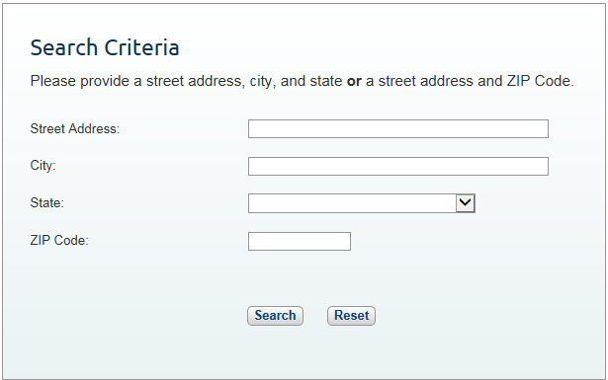

A "Yes" or "No" will show on the screen to indicate whether the location is in a HPSA area for that day only. If "Yes" append the AQ modifier. If "No", the address is not designated as a HPSA and no modifier should be used.

Note: Please make sure you are looking at eligibility for the right criteria, mental health vs. primary care.

Physicians should direct questions as to why a particular location is designated as a shortage area to the HRSA at [sdb@hrsa.gov](mailto:sdb@hrsa.gov). The full address of the site in question should be included. CMS is not involved in designating shortage areas.