Physician supervision of diagnostic tests

Section 410.32(b) of the Code of Federal Regulations requires that, with certain exceptions, diagnostic tests covered under §1861(s)(3) of the Social Security Act and payable under the physician fee schedule have to be performed under the supervision of an individual meeting the definition of a “physician”.

All diagnostic tests payable under the physician fee schedule must be furnished under at least a general level of physician supervision with the exception of certain procedures personally performed by the following:

* Independent qualified psychologists
* Clinical psychologists
* Qualified audiologists
* Physical therapists
* Qualified electrophysiologic clinical specialists (certified by the American Board of Physical Therapy Specialties)

Note: Some tests also require either direct or personal supervision.

The regulation defines the levels of physician supervision for diagnostic tests as follows:

* General supervision - the procedure is furnished under the physician’s overall direction and control, but the physician’s presence is not required during the performance of the procedure. Under general supervision, the training of the nonphysician personnel who actually performs the diagnostic procedure, and the maintenance of the necessary equipment and supplies are the continuing responsibility of the physician.
* Direct supervision in an office setting - the physician must be present in the office suite and immediately available to furnish assistance and direction throughout the performance of the procedure. It does not mean that the physician must be present in the room when the procedure is performed.
* Personal supervision - a physician must be in attendance in the room during the performance of the procedure.

This policy applies to technical components (TCs) (including TCs billed globally with the professional component (PC) of the procedure) and other diagnostic procedures, which do not have relative value units reflecting physician work. These supervision requirements do not apply to diagnostic tests furnished in hospitals.

Documentation maintained by the billing provider must be able to demonstrate that the required physician supervision is furnished. Services that are not performed under the appropriate supervision are not considered reasonable and necessary and, therefore, are not covered.

Code specific supervision levels

The level of supervision required for each diagnostic test is published by the Centers for Medicare & Medicaid Services as a part of the Medicare Physician Fee Schedule Database. To determine the level of supervision for a specific HCPCS or CPT code, please refer to the physician supervision and diagnostic procedures indicator, located under status indicators, on the Physician’s Fee Schedule Code Search & Downloads ([JH](http://www.novitas-solutions.com/webcenter/portal/MedicareJH/FeeLookup)) ([JL](http://www.novitas-solutions.com/webcenter/portal/MedicareJL/FeeLookup)), available on our website.

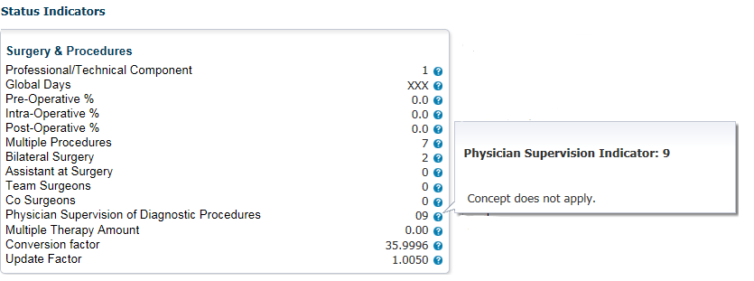

|  |  |
| --- | --- |
| Level | Description |
| 01 | Procedure must be performed under the general supervision of a physician. |
| 02 | Procedure must be performed under the direct supervision of a physician, independent psychologist or a clinical psychologist. |
| 03 | Procedure must be performed under the personal supervision of a physician. |
| 04 | Physician supervision policy does not apply when procedure is furnished by a qualified, independent psychologist or a clinical psychologist or furnished under the general supervision of a clinical psychologist; otherwise, must be performed under the general supervision of a physician. |
| 05 | Physician supervision policy does not apply when procedure personally furnished by a qualified audiologist, physician, or non-physician practitioner. Direct supervision by a physician is required for those parts of the test that may be furnished by a qualified technician when appropriate to the circumstances of the tests. |
| 06 | Procedure must be personally performed by a physician or a physical therapist who is certified by the ABPTS as a qualified electrophysiologic clinical specialist and is permitted to provide the service under State law. Procedure may also be performed by a PT with ABPTS certification without physician supervision. |
| 6a | Supervision standards for level 66 apply; in addition, the PT with ABPTS certification may supervise another PT but only the PT with ABPTS certification may bill. |
| 09 | Concept does not apply. |
| 21 | Procedure must be performed by a technician with certification under general supervision of a physician; otherwise, must be performed under direct supervision of a physician. Procedure may also be performed by a PT with ABPTS certification without physician supervision. |
| 22 | May be performed by a technician with on-line real-time contact with physician. |
| 66 | Procedure must be performed by a physician or by a PT with ABPTS certification and certification in this specific procedure. |
| 77 | Procedure must be performed by a PT with ABPTS certification (TC & PC) or by a PT without certification under direct supervision of a physician (TC & PC), or by a technician with certification under general supervision of a physician. (TC only; PC always physician). |
| 7a | Supervision standards for level 77 apply; in addition, the PT with ABPTS certification may personally supervise another PT but only the PT with ABPTS certification may bill. |

License practitioners

The following are authorized to supervise the performance of diagnostic tests in addition to physicians:

* Nurse practitioners
* Clinical nurse specialist
* Physician assistants

When NPs, CNSs, Pas personally perform diagnostic tests, the supervision/collaboration requirements under Section 1861 (s)(3) of the Act and 42CRF 410.32 don't apply. Rather, these practitioners are authorized to personally perform diagnostic tests under the supervision/collaborative requirements applicable to their practitioner benefit category pursuant to state scope of practice laws and under the applicable state requirements.

'Incident To' benefits

Diagnostic tests need not meet the incident to requirements because the diagnostic tests benefit set forth in §1861(s)(3) of the Act is separate and distinct from the incident to benefit set forth in §1861(s)(2) of the Act. Diagnostic tests can't be billed to Medicare as incident to services. Accordingly, the supervision requirements under the incident to benefit category aren't applicable to the diagnostic tests benefit category.

Reference

* [MLN Matters Supervision Requirements for Diagnostic Tests: Manual Update](https://www.cms.gov/files/document/mm13094-supervision-requirements-diagnostic-tests-manual-update.pdf)