Instructions for completing the EDI Enrollment form for providers
Providers should complete the Electronic Data Interchange (EDI) Enrollment (8292) form to enroll for electronic billing or to make changes in their existing electronic billing setup.
It is important that you use the most recent version of any EDI form when enrolling for EDI services or updating your existing EDI status. The following screenshots are for instructional purposes only and cannot be completed and submitted for enrollment.
This form must be completed and approved before attempting to register for an IDM User ID.
- Carefully follow the below block-by-block instructions to ensure accurate completion. Incomplete or inaccurate forms will be returned and need to be corrected and resubmitted.
- All fields marked with a red asterisk are required.
- Complete this form using Adobe or by typing online and then print to submit.
General Information
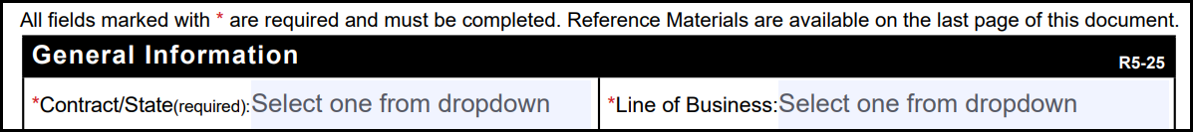
- Select the appropriate state from the dropdown.
- The state options are all the states included in the JH and JL MAC jurisdictions.
- Select the appropriate line of business from the dropdown.
- The line of business options are Part A (Institutional) or Part B (Professional).
- Your PTAN will either be enrolled under Part A - Institutions (Hospitals, nursing facility, hospice, etc.) or Part B - Professional (outpatient care, preventive services, ambulance services, durable medical equipment, etc.) For providers with both Part A and Part B PTANs, separate forms must be submitted for each.
Provider information
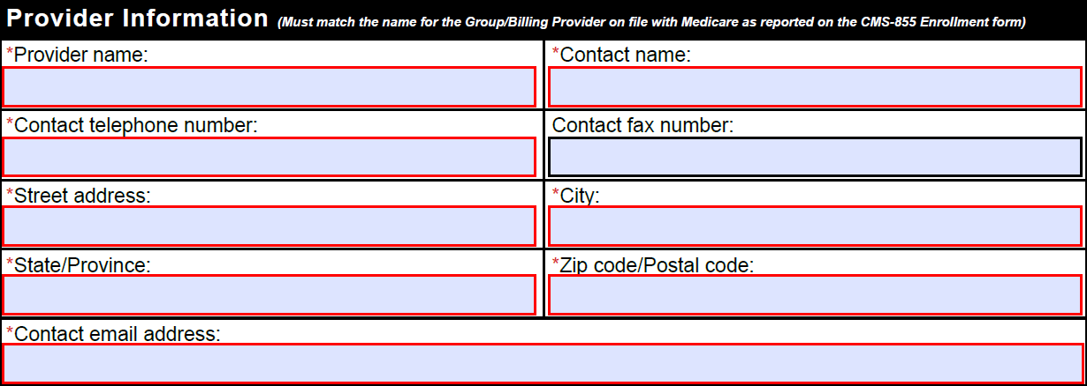
The provider information must match the name listed on file at Medicare. If the enrollment is for a group, use the group information, not the rendering physician information.
- Type the [group] provider name. Spell out names completely, without abbreviations.
The provider name indicated must match what was reported to Novitas on the CMS-855 Enrollment form.
- Type the contact person’s name that has knowledge and authority to answer questions regarding your enrollment.
- Type the contact person’s telephone number (including area code) and extension (if applicable).
- Type the fax number (including area code) for the provider.
- Type the practice mailing address, including suite/building numbers/levels.
- Type the email address of the contact person. This email address will be used for enrollment processing response.
- Type the [group] provider name.
Provider identification
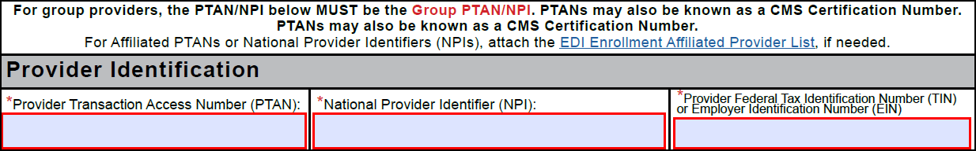
The PTAN, NPI and TIN/EIN are required and must match the numbers on file at Medicare for the provider being enrolled. The [group] billing information should be reported, not rendering physician information.
- Type the [group] Provider Transaction Access Number (PTAN) of the provider.
- If you are billing under a group PTAN, only one EDI Enrollment form should be completed using the group PTAN. The PTAN, NPI and TIN/EIN are required and must match the number on file at Medicare.
- Affiliated PTANS may be setup by attaching the EDI Enrollment Affiliated Provider List.
- Type the [group] National Provider Identifier (NPI) of the provider.
- The number reported MUST match the number on file at Medicare for the provider and must be linked to the PTAN provider on the form. This should not be the NPI for an individual member of the group.
- Part B Providers who have multiple NPIs linked to their PTAN are only required to submit one form with a valid PTAN/NPI combination listed. You do not need to submit separate forms for each NPI nor do you need to list all of the NPIs.
- Type the full Provider Federal Tax Identification Number (TIN) or Employer Identification Number (EIN) of the provider.
Type of request
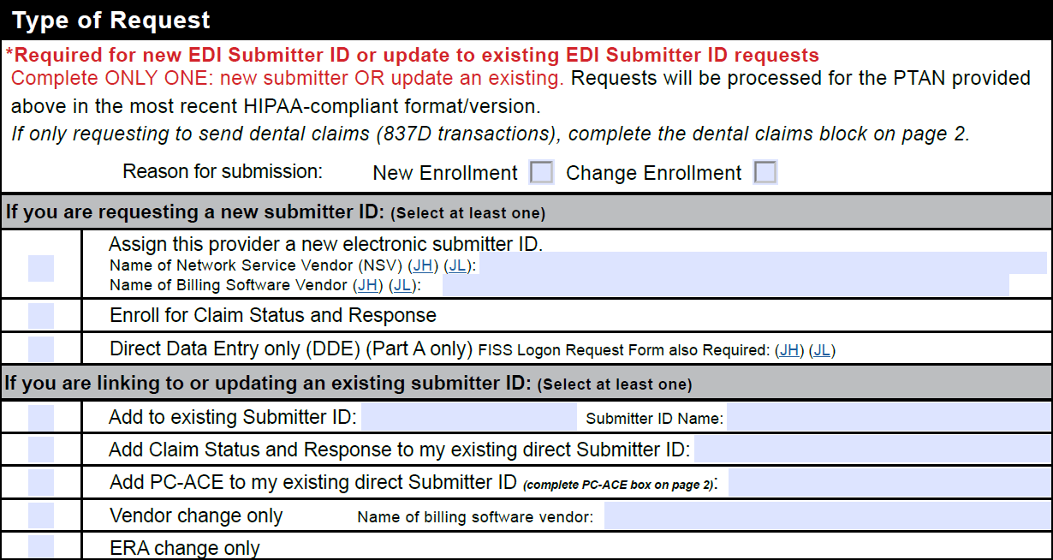
- Select one of the boxes to indicate the reason for submission.
- Complete only one of the sections with gray titles: the “If you are requesting a new submitter ID” section OR the “If you are linking to or updating an existing submitter ID” section. At least one option in either section is required. If nothing is selected, the form will be returned.
If you are requesting a new submitter ID for sending ANSI X12N 837 electronic claim files:
- Check the “Assign this provider a new electronic submitter ID” box if you will be connecting directly to First Coast for electronic billing.
- Type the name of your network service vendor and billing software vendor. Both vendor names are required to receive an electronic submitter ID and they both must be enrolled with Novitas.
- Check the ”Enroll for Claim Status and Response” box to be setup for the ANSI X12N 276/277 transactions. Verify your software vendor supports the 276/277 files before requesting this feature.
- Check the “Direct Data Entry only” box to request EDI enrollment for FISS/DDE use only.
- This is only available for Part A providers.
- The FISS Login Request Form is also required.
If you are linking to or updating an existing submitter ID:
- Check the “Add to existing Submitter ID” box and type the submitter ID and submitter ID name to be linked to an existing direct Submitter ID or to an existing billing service or clearinghouse Submitter ID. Both the Submitter ID and Submitter ID Name are required for this option. The information must be accurate and for the same jurisdiction/contract as the provider being enrolled.
- Check the “Add Claim Status and Response” box and type your existing direct Submitter ID to be setup for the ANSI X12N 276/277 transactions. Verify your software vendor supports the 276/277 files before requesting this feature.
- Check the “Add PC-ACE to my existing direct Submitter ID” box and type your existing direct Submitter ID if only requesting the PC-ACE software. Then check the “Yes, enroll for PC-ACE” box in the PC-ACE section on page two to agree to the software terms.
- Check the “Vendor Change only” box and provide the name of your new billing software vendor if only requesting to report a change in your software vendor. The new software vendor must be enrolled with Novitas.
- Check the “ERA Change only” box if you are only requesting to change to the electronic remittance advice (ERA) setup. Then provide the ERA change details in the ERA block on page two.
Dental claims
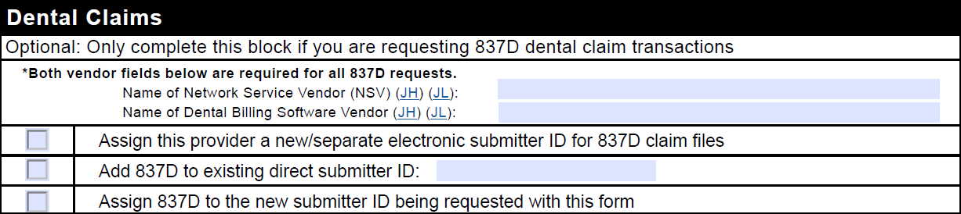
Only complete this block if you are submitting or retrieving dental claim files.
- Select only one option from the three boxes provided:
- Select the “Assign this provider a new/separate…” box if you are requesting a new submitter ID to submit the dental claims files separate from any other submitter IDs.
- Select the “Add 837D…” box if you would like to submit/retrieve dental claims through an existing direct submitter ID and type the complete existing submitter ID.
- Select the “Assign 837D to the new submitter ID…” box if you would like to add 837D to the new submitter ID that will be created when this form is processed based on the Type of Request selections.
Electronic remittance advice (ERA)
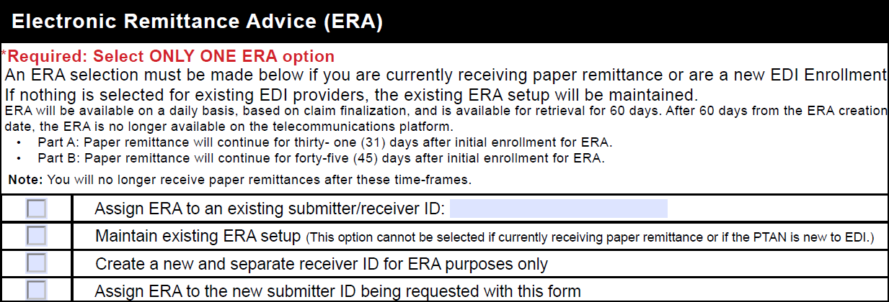
- Select ONLY ONE of the following options. ERA is a requirement for electronic billing.
- Select the “Assign ERA to an existing Novitasphere submitter/receiver ID” box if you would like to have the ERA file sent to an existing submitter/receiver ID and type the complete existing submitter ID where you would like your 835 files to be sent. Type only one existing ID. An accurate submitter ID is required for this option, and it must be for the same jurisdiction/contract as the provider being enrolled. Only one existing ID should be provided.
- Select the “Maintain existing ERA setup” box to keep your current ERA setup. This option cannot be selected if you are currently receiving paper remittances or a new provider.
- Select the “Create a new and separate receiver ID for ERA purposes only” box to have a new ID created to retrieve your ERA, separate from the submitter ID used to send claims.
- Select the “Assign ERA to the new submitter ID being requested” box if you would like to receive the ANSI X12N 835 file through the new submitter ID that will be created when this form is processed.
If no ERA option is selected, your existing ERA setup will be maintained. If nothing is selected and you do not currently receive ERA, the form will be returned.
Maintain existing submitter/Receiver ID
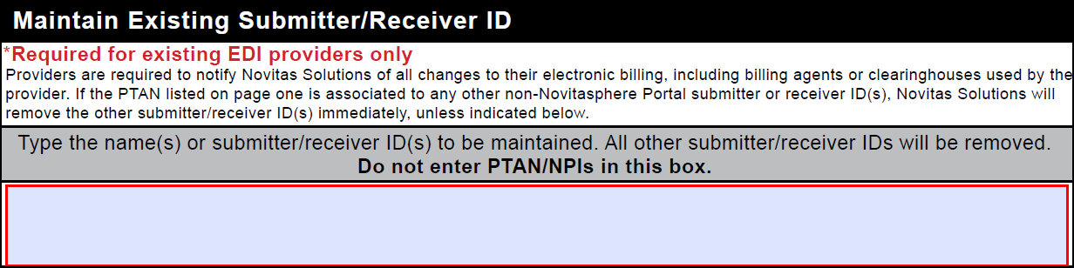
Skip this block if not currently enrolled for electronic billing or if do not need to maintain any existing submitter/receiver IDs.
All Novitasphere portal submitter IDs will be maintained automatically.
- Type the submitter/receiver’s name(s) or ID number(s) of any existing submitter/receiver ID(s) currently set up that should remain set up. Any non-portal submitter/receiver IDs linked to the provider will be removed if not provided in this block.
If you maintain a submitter to finalize any remaining billing, you can fax a request on letterhead to have them removed once billing is completed.
PC-ACE
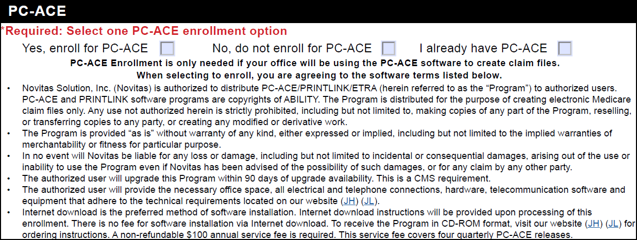
PC-ACE is a free software which can be used to create electronic claim files for submission, and to interpret electronic claim reports.
If a third-party billing service or clearinghouse is submitting the claims, it is not necessary for you to select the PC-ACE option unless you will also be submitting claims or needs the software to interpret reports.
PC-ACE does not provide a connection to Novitas. Therefore, you will need to acquire your own SFTP software to connect and send your claims, or you may enroll for Novitasphere Portal.
PC-ACE does not support Claim Status and Response (ANSI X12N 276/277) transactions.
- Select the "Yes, enroll for PC-ACE" box to request the free PC-ACE Medicare billing software.
- Read the software terms and technical requirements carefully before requesting to enroll for PC-ACE.
- Select the “No, do not enroll for PC-ACE” box if you do not want to use the PC-ACE software.
- Select “Yes” from the drop-down box to request or maintain the PC-ACE software.
Additional information
- This block is not required.
- Skip this block or check the Provider Tax Identification Number or National Provider Identifier box. Neither option will have any impact to your electronic billing setup.
Required signature
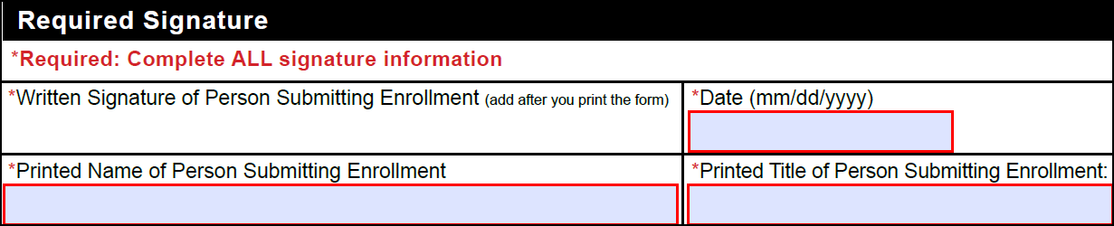
This is a required block. The form will be returned if any of these fields are not completed accurately.
- Read the full agreement, attestation, and authorized official signature requirement.
- Sign the written signature box after printing using a blue or black ink pen. Signatures typed in any font or stamped are not acceptable.
- Type or use the calendar dropdown to select the date the form was signed. The date must be a full month, day, and year.
- Type the complete printed name of the person signing the form.
- Type the professional title of the person signing the form.
Form submission

- Review the entire form to verify the information provided is accurate and complete. All fields with a red asterisk must be completed.
- Print the form.
- Sign the written signature box after printing using a blue or black ink pen. Signatures typed in any font or stamped are not acceptable.
- Fax the form to 1-877-439-5479 or mail to the address provided. Complete only one form of submission. Do not mail paper forms if it was faxed.
- Fax is recommended due to potential delays with mail delivery.
- Do not send duplicate forms.
- Watch for your enrollment response and follow the instructions provided.
- Allow up to two weeks for processing.

