Novitasphere Portal User Manual Supplement: Claim submission/ERA using TIBCO

The TIBCO PartnerExpress system is available in the Novitasphere portal’s Claims submission/ERA feature. This system allows you to submit electronic claims via batch files (837) and retrieve the electronic reports through the TIBCO PartnerExpress EDI gateway.

This supplement provides instruction for the TIBCO system AFTER accessing it through Novitasphere. For instructions on accessing Novitasphere, or utilizing any of the other features, refer to the [Novitasphere User Guide](ddocname:00298193).

Below is the home screen of TIBCO seen once accessed through the Claim submission/ERA feature in Novitasphere:

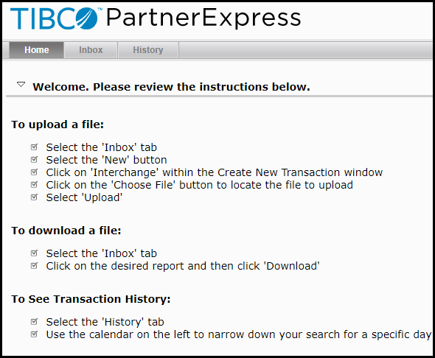

To submit an 837-claim file and retrieve reports:

1. Click on the Inbox tab.

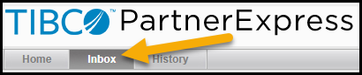

1. Click on the New button.

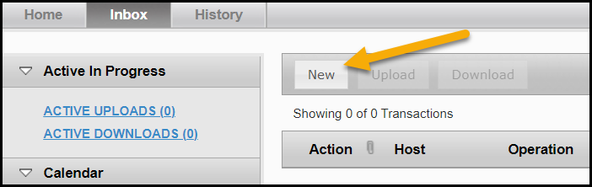

1. Select Interchange.

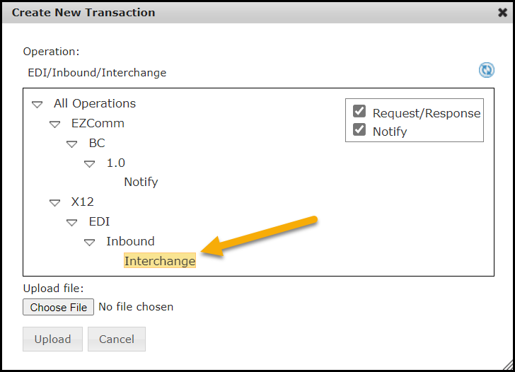

1. Click Choose File and then navigate to the claim file. The location will depend on where your claim creation software saves the file. If unable to locate the file, please contact your software vendor.

If you are using the PC-ACE software available through Novitas, navigate to the WINPCACE folder and look for the file named TRANS.DAT for Part A and TRANSB.DAT for Part B files.

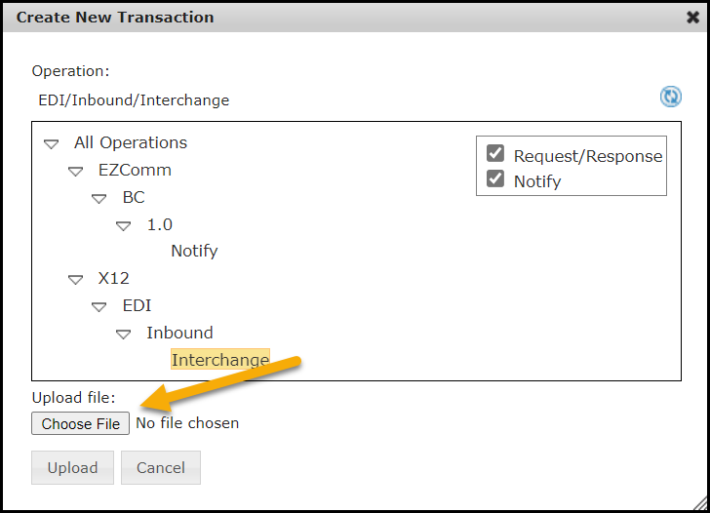

1. Select the file(s) and click Open. The selected file will display in “Upload file” textbox.
2. Click Upload to submit the file.

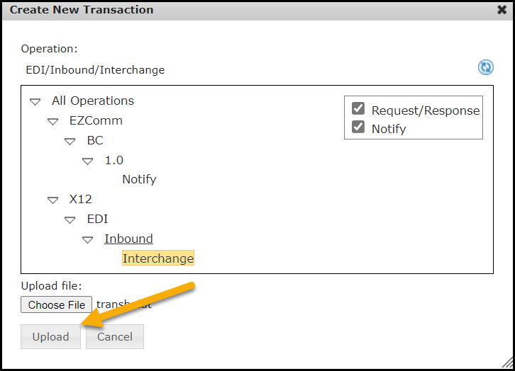

1. “A new upload working” pop-up message will be displayed briefly.

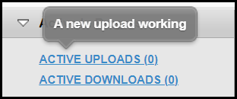

1. Retrieve the 999 Acknowledgement Report. This report will display in the Inbox a few minutes after submitting an 837 claim file. This report will tell you if the file is initially accepted or rejected. If rejected, the report will give the reason for rejection.

Click on the Inbox tab and look for the Transaction ID starting with 999.

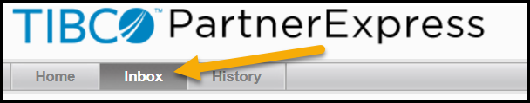

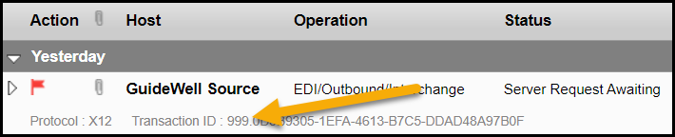

1. Select the report from the Inbox list and click Download.

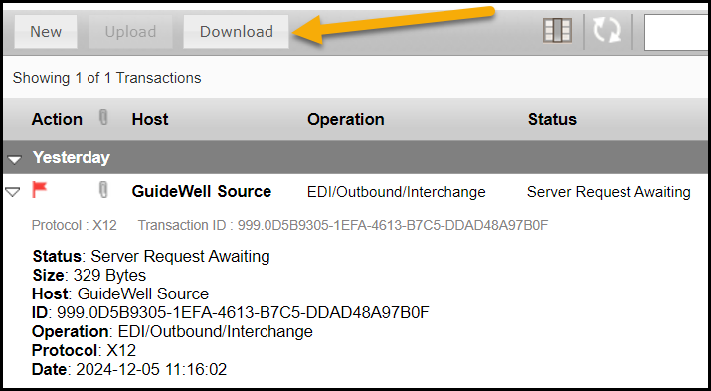

1. Change the File name ending from .dat to .txt.

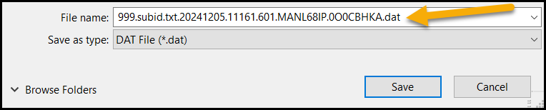

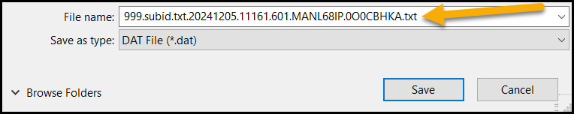

1. Change the ‘Save as type’ field to ‘All Files (*.*)’.

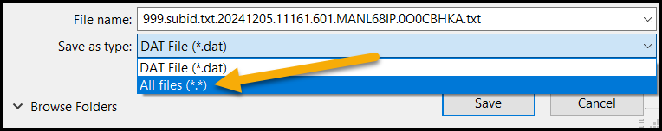

1. Navigate to the proper location on your computer and click Save.
2. Open and interpret the 999 Acknowledgement Report. This report is not reader-friendly and will require software to interpret. The below resources are available to assist with interpretation:

* [Understanding the 999 Implementation Acknowledgement Report](http://www.novitas-solutions.com/webcenter/content/conn/UCM_Repository/uuid/dDocName:00004759)
* PC-ACE software ([JH](https://www.novitas-solutions.com/webcenter/portal/MedicareJH/pagebyid?contentId=00004595))([JL](https://www.novitas-solutions.com/webcenter/portal/MedicareJL/pagebyid?contentId=00004595)) – provides the 999 and 277CA reports in a reader-friendly format

1. Retrieve the 277CA Claims Acknowledgement Report. This report will display in the Inbox a few minutes after a 999 Acknowledgement Report without any errors. This report will tell you if each claim was accepted for processing or was rejected. If rejected, the report will give the reason for rejection.
2. Click on the Inbox tab and look for the Transaction ID starting with 277CA.
3. Select the report from the Inbox list and click Download.
4. Change the File name ending from .dat to .txt.hange the ‘Save as type’ field to ‘All Files (*.*)’.
5. Navigate to the proper location on your computer and click Save.
6. Open and interpret the 277CA Claims Acknowledgement Report. This report is not reader-friendly and will require software to interpret. The below resources are available to assist with interpretation:

* [Understanding the 277CA Claims Acknowledgement Report](http://www.novitas-solutions.com/webcenter/content/conn/UCM_Repository/uuid/dDocName:00004758)
* 277CA Rejection Code Lookup ([JH](https://www.novitas-solutions.com/webcenter/portal/MedicareJH/277CARejectCodeLookup))([JL](https://www.novitas-solutions.com/webcenter/portal/MedicareJL/page/277CARejectCodeLookup)) tool
* PC-ACE software ([JH](https://www.novitas-solutions.com/webcenter/portal/MedicareJH/pagebyid?contentId=00004595))([JL](https://www.novitas-solutions.com/webcenter/portal/MedicareJL/pagebyid?contentId=00004595)) – provides the 999 and 277CA reports in a reader-friendly format.

1. If Electronic Remittance Advice (ERA) files were setup to your Novitasphere portal submitter ID at the time of enrollment, open and interpret the 835 ERA file.
2. Click on the Inbox tab and look for the Transaction ID starting with 835.
3. Select the report from the Inbox list and click Download.
4. Change the File name ending from .dat to .txt.
5. Change the ‘Save as type’ field to ‘All Files (*.*)’.
6. Navigate to the proper location on your computer and click Save.
7. Open and interpret the 835 ERA. This report is not reader-friendly and will require software to interpret. Novitas Solutions offers the following free software options for this function:

* [PC-Print](ddocname:00004608) for Part A ERA
* [Medicare Remit Easy Print (MREP)](ddocname:00084216) for Part B ERA

Identifying crossover claims on the electronic remittance advice (ERA)

If the insurer has a Coordination of Benefits Agreement (COBA) with Medicare, then Medicare will crossover and transmit enrollee eligibility data and Medicare adjudicated claim data to the supplemental insurer. For more information, visit the [COBA webpage](https://www.novitas-solutions.com/webcenter/portal/MedicareJL/pagebyid?contentId=00008254#TopOfPage). Using the Novitasphere Claim Submission/ERA feature, the crossover information can be found on the ANSI 835 ERA in the "TRANSFER TO (COB)" field. The Trading Partner's ID will be in the "ID CODE" field on the ERA. If the claim crossed over to multiple Trading Partners, only the first one will be listed on the ERA. Using the Trading Partner ID, you can look up the other insurer that the claim crossed over to here: [COBA Trading Partners Customer Service Contacts - June 2022](https://www.cms.gov/files/document/coba-trading-partners-customer-service-contacts-june-2022.pdf) (list of automatic crossover Trading Partners in production).